Hardware Components of a Computer

Hardware Components of a computer refers to the collection of physical parts of a computer system that we can touch or feel. This includes the computer case, monitor, keyboard, and mouse. It also includes all the parts inside the computer case, such as the hard disk drive, motherboard, video card, and many others.

The hardware components of a computer or personal computer is categorized into 4 primary categories: -

1. System Unit
2. Display Device
3. Input Devices
4. External Devices

# System Unit

A System Unit is the main component of a personal computer, which houses the other devices necessary for the computer to function. It is comprised of a chassis and the internal components of a personal computer such as the system board (mother board), the microprocessor, memory modules, disk drives, adapter cards, the power supply, a fan or other cooling device and ports for connecting external components such as monitors, keyboards, mice, and other devices.

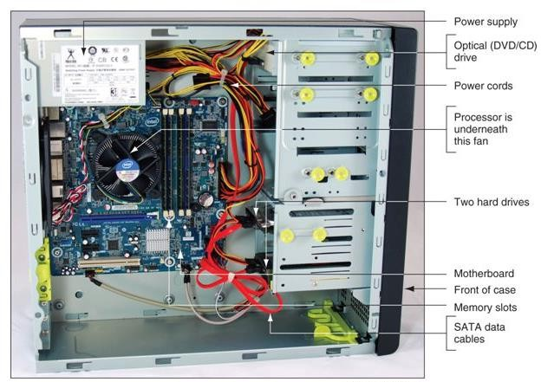

***System Unit Components***

# Display Devices

A display device is a personal computer component and is an output device that enables user to view the text and graphical data associated with a computer program. Display devices commonly connect to the system unit via a cable, and they have controls to adjust the settings for the device. They vary in size and shape, as well as the technology used.

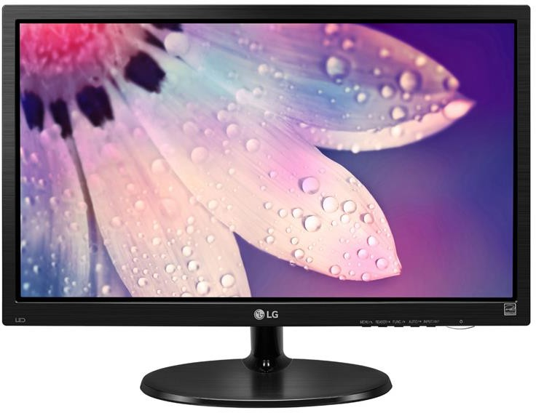

***Display* Device**

# Input Devices

An input device is a personal computer component that enables users to enter data or instructions into a computer. The most common input devices are keyboards and computer mice. Input devices can connect to the system via a cable or a wireless connection.

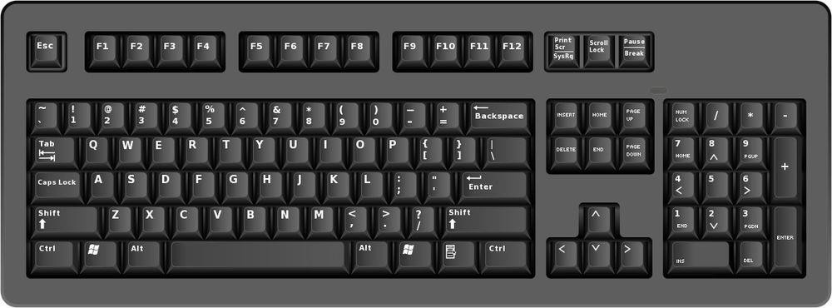

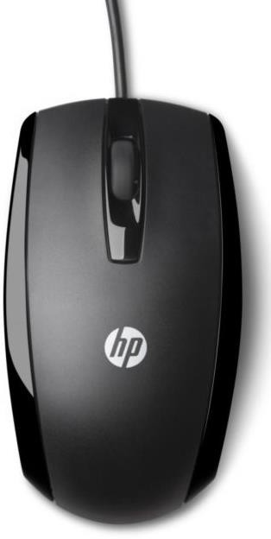**Keyboard**

**Mouse**

# External Devices

Any peripherals devices that are not housed inside the system unit are inherently external devices. A personal computer’s functionality can be enhanced by connecting different types of external devices to the system unit, often called peripherals devices. These devices typically provide alternative input or output methods or additional data storage. External devices are connected to the system unit via a cable or wireless connection. Some of them have their own power source and some draw power from the system.

There are several categories of external devices.

|  |  |  |
| --- | --- | --- |
| **External Devices** | | **Functionality** |
|  | Microphone | Provides audio input |
|  | Digital camera | Provides graphical input |
|  | Scanner | Provides graphical input |
|  | Speaker | Provides audio output |
|  | Printer | Provides printed output |
|  | Network device | Provides communication with other computers, such as access to the Internet. |
|  | External device | Provides additional data storage |

# System Unit Components

* 1. The System Board
  2. Central Processing Unit
  3. Memory
  4. Power Supplies
  5. Cooling Systems etc.

1. The System Board

The system board is the personal computer component that acts as the backbone for the entire computer system as it serves as a single platform to connect all of the parts of a computer together. It connects the CPU, memory, hard drives, optical drives, video card, sound card, and other ports and expansion cards directly or via cables. System Board is also known as motherboard. It consists of a large, flat circuit board with chips and other electrical components on it.

Some popular manufacturers of the motherboard are: -

* + Intel
  + Asus
  + Gigabyte
  + Biostar
  + Msi

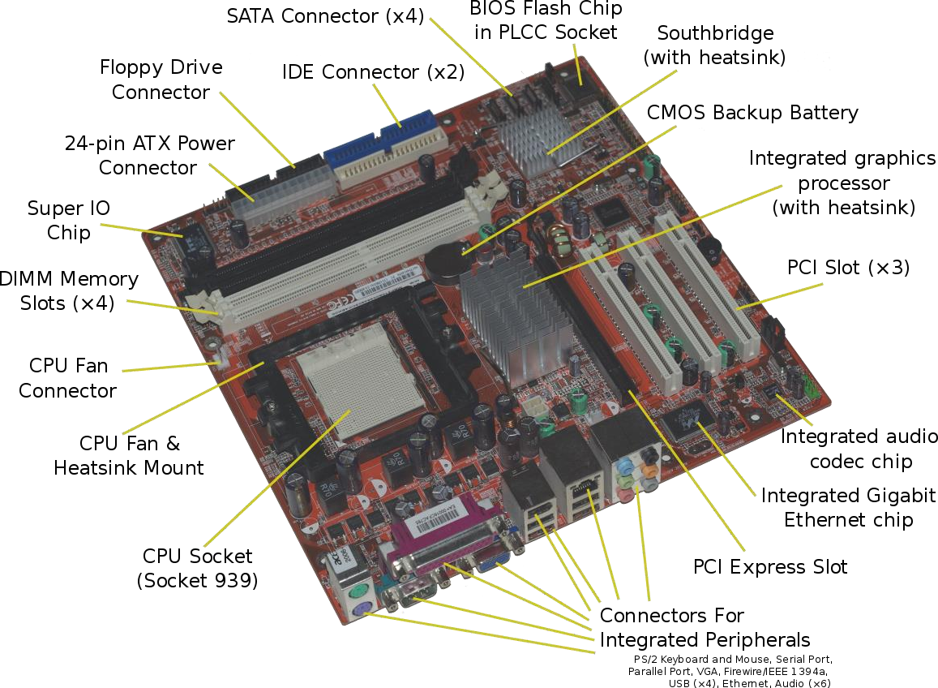

**System Board or Motherboard**

1. Central Processing Unit (CPU)

The Central Processing Unit (CPU), sometimes called microprocessor or just processor, is the real brain of the computer and is where most of the calculations take place.

Some popular manufacturers / designers of the CPU are: -

* + Intel
  + AMD
  + Qualcomm
  + Media Tek
  + NVIDIA

Central Processing Unit (CPU) consists of the following features: -

* + CPU is considered as the brain of the computer.
  + CPU performs all types of data processing operations.
  + It stores data, intermediate results, and instructions (program).
  + It controls the operation of all parts of the computer.

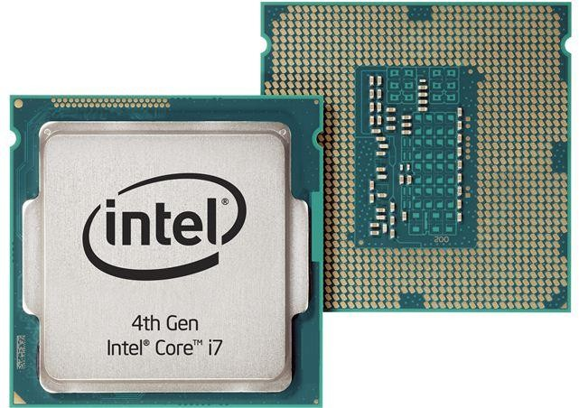

**Central Processing Unit (CPU)**

Now, the CPU itself has following three components: -

* + Memory or Storage Unit
  + Control Unit
  + Arithmetic Logic Unit (ALU)

Input Unit

CPU

Arithmetic & Logic Unit

Control Unit

Memory Unit

Output Unit

* + Memory or Storage Unit: This unit stores data, instructions & results for processing and stores the final results of processing before these results are released to an output device. It is also responsible for the transmission of all inputs and outputs.
  + Control Unit (CU) : This unit controls the operations of all parts of the computer but does not carry out any actual data processing operations.
  + Arithmetic and Logic Unit (ALU): All calculations are performed in the Arithmetic Logic Unit (ALU) of the computer. It also does comparison and takes decision. The ALU can perform basic operations such as addition, subtraction, multiplication, division, etc and does logic operations viz, >, <, =, ‘etc. Whenever calculations are required, the control unit transfers the data from storage unit to ALU once the computations are done, the results are transferred to the memory unit by the control unit and then it is send to the output unit for displaying results.

1. Memory

“Discussed in the Input, Output and Storage Devices Topic”.

Go through the Page No. 8 & 9 in the link provided below.

[http://www.dspmuranchi.ac.in/pdf/Blog/Input,%20Output%20and%20Memory%20Devices.pdf](http://www.dspmuranchi.ac.in/pdf/Blog/Input%2C%20Output%20and%20Memory%20Devices.pdf)

1. Power Supply

Power Supply known as switch-mode power supply (SMPS) is an electronic circuit that converts power using switching devices that are turned on and off at high frequencies, and storage components such as inductors or capacitors to supply power when the switching device is in its non-conduction state.

Switching power supplies have high efficiency and are widely used in a variety of electronic equipment, including computers and other sensitive equipment requiring stable and efficient power supply.

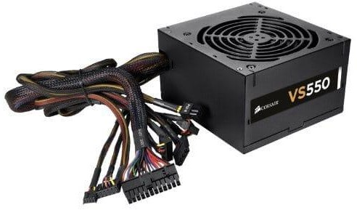

***SMPS***

1. Cooling System

Cooling may be required for CPU, Video Card, Mother Board, Hard Drive, etc. Without proper cooling, the computer hardware may suffers from overheating. This overheating causes slow downs, system error messages, and crashing. Also, the life expectancy of the PC's components is likely to diminish. The following are commonly used techniques for cooling the PC or Server components:

* + Heat Sinks
  + CPU/Case Fans
  + Thermal Compound
  + Liquid Cooling Systems

**Heat Sinks:** The purpose of a heatsink is to conduct the heat away from the processor or any other component (such as chipset) to which it is attached. Thermal transfer takes place at the surface of a heatsink. Therefore, heat sinks should have a large surface area. A commonly used technique to increase the surface area is by using fins. A typical processor heat sink is shown in the figure below:

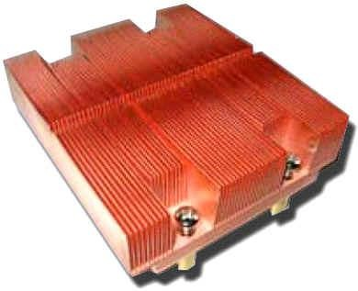

Intel Dual Core Xeon LGA 771 heatsink

**Fan:** The Fan is primarily used to force cooler air in to the system or remove hot air out of the system. A fan keeps the surrounding cooler by displacing air around the heatsink and other parts of the computer. A typical CPU fan is shown below.

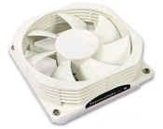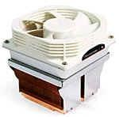

**CPU Fan Heatsink with Fan**

**Thermal Compound:** A thermal compound is used for maximum transfer of heat from CPU to the heatsink. The surface of a CPU or a heatsink is not perfectly flat. If you place a heatsink directly on a CPU, there will be some air gaps between the two. Air is a poor conductor of heat. Therefore, an interface material with a high thermal conductivity is used to fill these gaps, and thus improve heat conductivity between CPU and heatsink.

**Liquid Cooling Systems:** Like a radiator for a car, a liquid cooling system circulates a liquid through a heat sink attached to the processor. First, the cooler liquid passes through the heatsink, and then gets hot due to transfer of heat from the processor to the heatsink. Then the hot liquid passes through the radiator at the back of the case, and transfers the heat to the secondary coolant (air). Now, the liquid is cool enough to pass through the hot processor heatsink, and the cycle repeats. The chief advantage of LCS (Liquid Cooling System) is that the cooling takes place very efficiently (since liquids transfer heat more efficiently than air/solids). The dis- advantages include bulkier cooling system, cost, and additional reliability issues associated with LCS.